Tom Sawyer
Whitewashing the fence
The cast:
Aunt Polly-
Tom-
Jim-
Joe-
Billy-
Johny-
Ben-
Scene1
Aunt Polly: Tom! Tom! You-Tom! Wake up! Did you expect to sleep through Saturday?
Tom: I forgive you, Aunt Polly.
Aunt Polly: You forgive me? I`ll forgive you when you`ve whitewashed that fence like I told you .
Tom: But what about my finger?
Aunt Polly: Your what? Now get up and take your finger with you! Two coats a whitewash, Tom! Do you hear me?
(Jim appears)
Aunt Polly: Jim, get a bucket and fetch the water from town.
Jim: Yes mam.
(Jim and Aunt Polly leaves)
Scene2
(Tom is painting the fence)
Tom: Hi Jim!
Jim: Hi Tom!
Tom: I`ll fetch the water for you, if you`ll whitewash the fence.
Jim: I can`t Tom. Miss Polly told me to go to town but not to fool around with anybody. She suspected you asking me. That`s why she told me not to do it.
Tom: Oh, never mind! Give me that bucket. She won`t ever know. I`ll give you a marble.
Jim: What a nice marble. But Aunt Polly….
Tom: If you whitewash the fence, I`ll show you my finger.
Jim: your finger!
(Tom starts to unwind the bandage around his finger. Jim bends over it with interest. Aunt Polly appears unseen by the boys. Jim picks his bucket and runs away. Aunt Polly twists Tom`s ear. He starts to whitewash the fence.)
Scene 3
(Joe appears)
Joe: Hi Tom! What are you doing? Why do you have to work on Saturday?
Tom: Oh, It`s you, Joe.
Joe: I`m going to go swimming. Do you want to come? Oh, no! You would work, wouldn`t you?
Tom: Tom Sawyer likes to work.
Joe: Oh, come on….
Tom: Do you have a chance to whitewash every day?
Joe: Let me whitewash a little.
Tom: Oh no! Aunt Polly is particular about this fence.
Joe: Oh, come on! Just let me try! I`ll give you half of my apple if you let me.
Tom: No!
Joe: I`ll give you the whole apple!
Tom: OK.
(Tom hands over the brush, takes the apple, Joe starts working)
Scene4
(Billy Fisher appears)
Billy: Hi Joe! What are you doing?
Joe: Tom lets me whitewash to fence for him.
Billy: What do you mean?
Joe: I gave him an apple for a chance to do it.
Billy: Tom, I`ll give you my kite, if you let me whitewash.
Tom: OK.
(Joe hands over the brush, Billy gives a kite to Tom, Joe leaves and Billy starts working)
Scene5
(Johny Miller appears)
Johny: Hi Billy! What are you doing?
Billy: Tom lets me whitewash the fence for him.
Johny: What do you mean?
Billy: I gave him my kite for a chance to do it.
Johny: I found a dead rat yesterday. I`ll give you my rat, if you let me do it.
Tom: OK.
(Billy hands over the brush, Johny gives Tom the dead rat, Billy goes away, Johny starts working.)
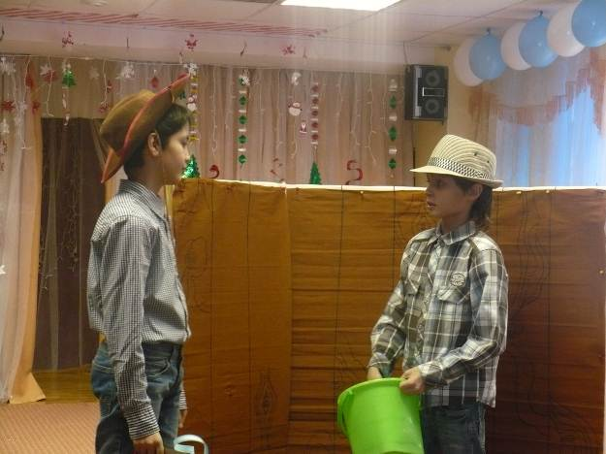
Scene6
(Ben appears)
Ben: Hi Johny! What are you doing?
Johny: Tom lets me whitewash the fence for him.
Ben: What do you mean?
Johny: I mean I gave him a dead rat with a string to do it.
Ben: Tom, I`ll give you a piece of chalk if you let me do it.
Tom:OK.
(Johny hands over the brush, Ben gives Tom a piece of chalk, Johny goes away, Ben starts working, Ben goes away)
Scene 7
(Aunt Polly appears)
Aunt Polly: You can`t be done already.
Tom: But I am.
Aunt Polly: Tom, you can work. Come to the kitchen, a tasty pudding is waiting for you.

